**Module 8 introduction**

**Learning objectives**

In this module, you will learn how to:

* Describe AWS pricing and support models.
* Describe the AWS Free Tier.
* Describe key benefits of AWS Organizations and consolidated billing.
* Explain the benefits of AWS Budgets.
* Explain the benefits of AWS Cost Explorer.
* Explain the primary benefits of the AWS Pricing Calculator.
* Distinguish between the various AWS Support Plans.
* Describe the benefits of AWS Marketplace.

**Video transcript**

–

Well, now that Morgan is the owner of the coffee shop, she probably has a lot of logistics to worry about as well as all the costs that come with this added responsibility. Costs like the building lease, the tables, the cost of the employees, of course. What about taxes? What about power, and heating, and air conditioning? And what about the groundskeepers who keep the outside looking so nice? And a much more important question is, how much is it going to cost next month to keep the store open? There's really a lot of moving parts.

We certainly could get a good ballpark of how much it costs per month and just estimate what next month might be, knowing that it's about to start of the busy season. In order to get the exact amount, we need to know how much each item costs and how many of them we're planning to use next month. Put them in a table and that'll calculate the prediction. Done.

Now, we might also be asking questions about what it might cost to move to an entirely different city, and what would be the cost differential there? All of these questions are exactly the kinds of questions that we're going to answer in this next section, as we talk about pricing and support. And spoiler alert, AWS provides a lot of free tools to help you plan and analyze your budgets for your AWS environments. Let's dive on in

# AWS Free Tier

**Video transcript**

–

So you've created a brand spanking new AWS account and want to get started, but you're worried about exhausting your credit limit. Well, don't worry. If you're looking to try out some AWS services, you might be able to try them out under our Free Tier.

Depending on the product you're looking at, the Free Tier offers three different ways to try out a service. Number one, always free. That means a service is available to all AWS customers and the Free Tier does not expire. Number two, 12 months free. That means you have 12 months to try out a service following your initial signup date to AWS, so the date you created your AWS account. And number three, trials. Some services offer a short-term free trial, and then they expire after that period ends.

Simple enough, right? Let's illustrate with a few examples. Let's take AWS Lambda, our serverless compute option. As of March 2020, it allows for one million free invocations per month. That means if you stay under one million invocations, it's always free. This Free Tier never expires. Another example is S3, our object store service. It's free for 12 months for up to five gigs of storage. Thereafter, you'll incur a cost. Great for trying out a static website on S3, I might say. And the last example is Lightsail where you can deploy ready-made application stacks. We offer a one month trial of up to 750 hours of usage. That's a pretty decent amount to deploy and test a WordPress blog. I mean, who knows, maybe you wanna show people your smoothie recipes.

But before I digress, some other services that qualify under the free tier are SageMaker, Comprehend Medical, DynamoDB, SNS, Cognito, and so much more. If you want to see the full list of 60 or so services, please check out our Resources section. Happy exploring of the Free Tier.

**AWS Free Tier**

The [AWS Free Tier](https://aws.amazon.com/free/) enables you to begin using certain services without having to worry about incurring costs for the specified period.

Three types of offers are available:

* Always Free
* 12 Months Free
* Trials

For each free tier offer, make sure to review the specific details about exactly which resource types are included.

To learn more, select the **+** symbol next to each category.

**Always Free**

–

These offers do not expire and are available to all AWS customers.

For example, AWS Lambda allows 1 million free requests and up to 3.2 million seconds of compute time per month. Amazon DynamoDB allows 25 GB of free storage per month.

**12 Months Free**

–

These offers are free for 12 months following your initial sign-up date to AWS.

Examples include specific amounts of Amazon S3 Standard Storage, thresholds for monthly hours of Amazon EC2 compute time, and amounts of Amazon CloudFront data transfer out.

**Trials**

–

Short-term free trial offers start from the date you activate a particular service. The length of each trial might vary by number of days or the amount of usage in the service.

For example, Amazon Inspector offers a 90-day free trial. Amazon Lightsail (a service that enables you to run virtual private servers) offers 750 free hours of usage over a 30-day period.

# AWS pricing concepts

**How AWS pricing works**

AWS offers a range of cloud computing services with pay-as-you-go pricing.

To learn more, select the **+** symbol next to each category.

**Pay for what you use.**

–

For each service, you pay for exactly the amount of resources that you actually use, without requiring long-term contracts or complex licensing.

**Pay less when you reserve.**

–

Some services offer reservation options that provide a significant discount compared to On-Demand Instance pricing.

For example, suppose that your company is using Amazon EC2 instances for a workload that needs to run continuously. You might choose to run this workload on Amazon EC2 Instance Savings Plans, because the plan allows you to save up to 72% over the equivalent On-Demand Instance capacity.

**Pay less with volume-based discounts when you use more.**

–

Some services offer tiered pricing, so the per-unit cost is incrementally lower with increased usage.

For example, the more Amazon S3 storage space you use, the less you pay for it per GB.

**AWS Pricing Calculator**

The [**AWS Pricing Calculator**](https://calculator.aws/#/) lets you explore AWS services and create an estimate for the cost of your use cases on AWS. You can organize your AWS estimates by groups that you define. A group can reflect how your company is organized, such as providing estimates by cost center.

When you have created an estimate, you can save it and generate a link to share it with others.

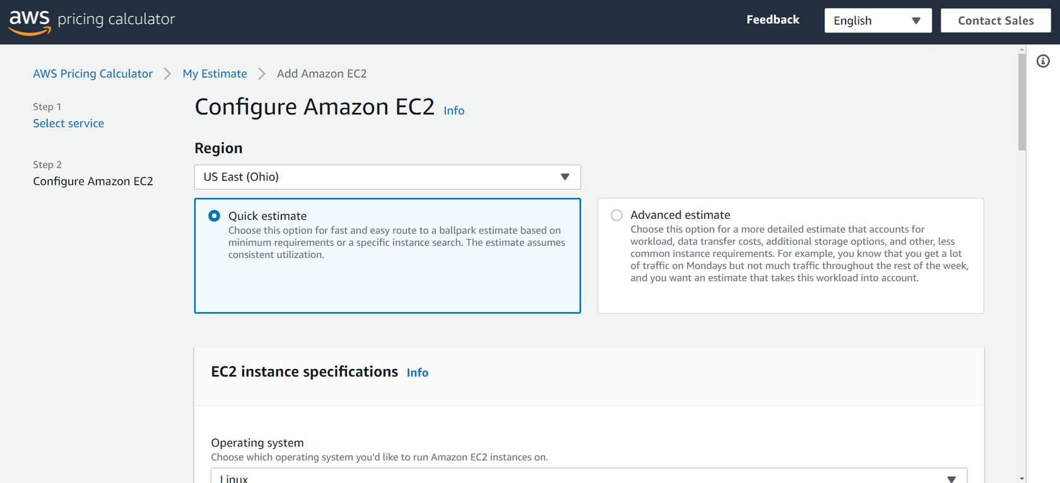

Suppose that your company is interested in using Amazon EC2. However, you are not yet sure which AWS Region or instance type would be the most cost-efficient for your use case. In the AWS Pricing Calculator, you can enter details such as the kind of operating system you need, memory requirements, and input/output (I/O) requirements. By using the AWS Pricing Calculator, you can review an estimated comparison of different EC2 instance types across AWS Regions.

**AWS pricing examples**

This section presents a few examples of pricing in AWS services.

**AWS Lambda**

To learn more about [AWS Lambda pricing](https://aws.amazon.com/lambda/pricing/), select each tab.

AWS LAMBDA PRICINGP

For AWS Lambda, you are charged based on the number of requests for your functions and the time that it takes for them to run.

AWS Lambda allows 1 million free requests and up to 3.2 million seconds of compute time per month.

You can save on AWS Lambda costs by signing up for a Compute Savings Plan. A Compute Savings Plan offers lower compute costs in exchange for committing to a consistent amount of usage over a 1-year or 3-year term. This is an example of **paying less when you reserve**.

RICING EXAMPLE

If you have used AWS Lambda in multiple AWS Regions, you can view the itemized charges by Region on your bill.

In this example, all the AWS Lambda usage occurred in the Northern Virginia Region. The bill lists separate charges for the number of requests for functions and their duration.

Both the number of requests and the total duration of requests in this example are under the thresholds in the AWS Free Tier, so the account owner would not have to pay for any AWS Lambda usage in this month.

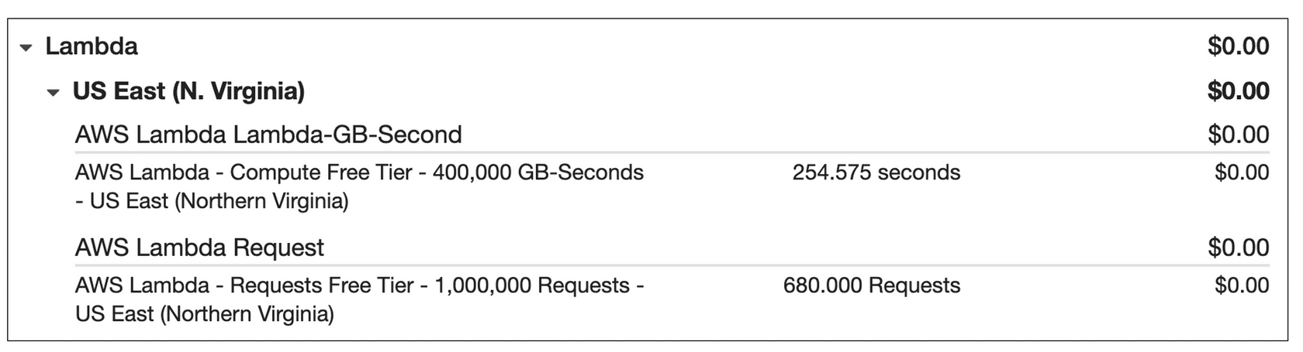

**Amazon EC2**

To learn more about [Amazon EC2 pricing](https://aws.amazon.com/ec2/pricing/), select each tab.

AMAZON EC2 PRICING

With Amazon EC2, you pay for only the compute time that you use while your instances are running.

For some workloads, you can significantly reduce Amazon EC2 costs by using Spot Instances. For example, suppose that you are running a batch processing job that is able to withstand interruptions. Using a Spot Instance would provide you with up to 90% cost savings while still meeting the availability requirements of your workload.

You can find additional cost savings for Amazon EC2 by considering Savings Plans and Reserved Instances.

PRICING EXAMPLE

The service charges in this example include details for the following items:

* Each Amazon EC2 instance type that has been used
* The amount of Amazon EBS storage space that has been provisioned
* The length of time that Elastic Load Balancing has been used

In this example, all the usage amounts are under the thresholds in the AWS Free Tier, so the account owner would not have to pay for any Amazon EC2 usage in this month.

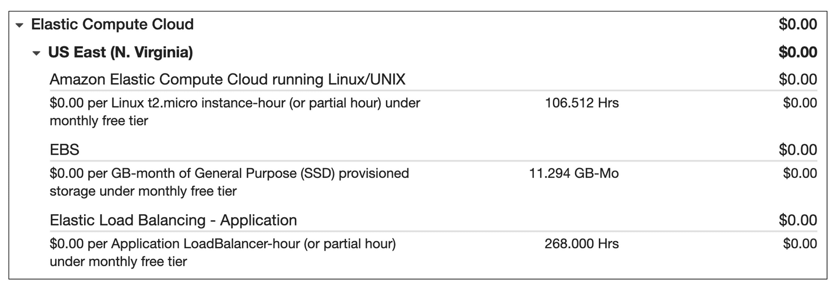

**Amazon S3**

To learn more about [Amazon S3 pricing](https://aws.amazon.com/s3/pricing/), select each tab.

AMAZON S3 PRICING

For Amazon S3 pricing, consider the following cost components:

* **Storage -**You pay for only the storage that you use. You are charged the rate to store objects in your Amazon S3 buckets based on your objects’ sizes, storage classes, and how long you have stored each object during the month.
* **Requests and data retrievals -**You pay for requests made to your Amazon S3 objects and buckets. For example, suppose that you are storing photo files in Amazon S3 buckets and hosting them on a website. Every time a visitor requests the website that includes these photo files, this counts towards requests you must pay for.
* **Data transfer -**There is no cost to transfer data between different Amazon S3 buckets or from Amazon S3 to other services within the same AWS Region. However, you pay for data that you transfer into and out of Amazon S3, with a few exceptions. There is no cost for data transferred into Amazon S3 from the internet or out to Amazon CloudFront. There is also no cost for data transferred out to an Amazon EC2 instance in the same AWS Region as the Amazon S3 bucket.
* **Management and replication -** You pay for the storage management features that you have enabled on your account’s Amazon S3 buckets. These features include Amazon S3 inventory, analytics, and object tagging.

PRICING EXAMPLE

The AWS account in this example has used Amazon S3 in two Regions: Northern Virginia and Ohio. For each Region, itemized charges are based on the following factors:

* The number of requests to add or copy objects into a bucket
* The number of requests to retrieve objects from a bucket
* The amount of storage space used

All the usage for Amazon S3 in this example is under the AWS Free Tier limits, so the account owner would not have to pay for any Amazon S3 usage in this month.

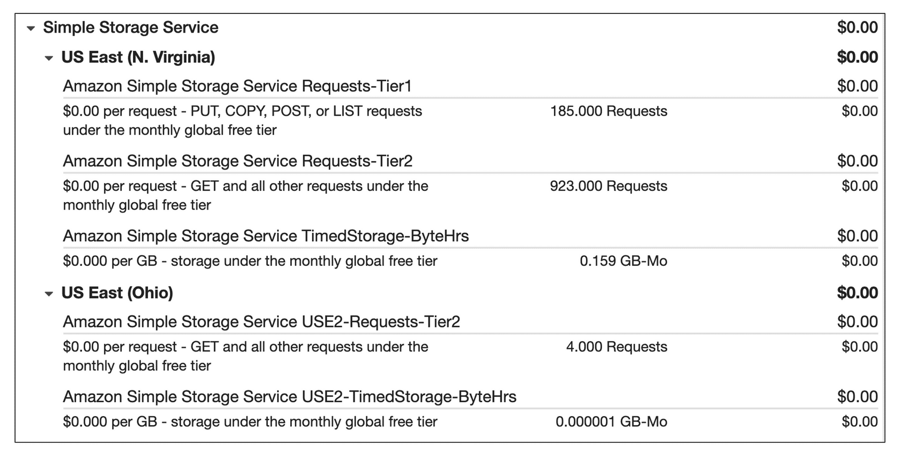

**Billing dashboard**

Play Video

**Video transcript**

–

Hey there, AWS aficionados. Are you like me and curious about billing information of your AWS account? Well, let's walk through a demo so you know where to go.

As you can see, I'm already logged in and now we're gonna search for billing and click the option that shows up. And boom, with that, you already have some useful information. You can see your month-to-date spend on the right-hand side with the top services being used. Below on the left is the last month, current and forecasted amounts. Below that is the top Free Tier services by usage. You even get the percentages of your month-to-date usage. Nifty, right?

If we scroll up, you can see you have access to other billing tools, such as Cost Explorer, Budgets, along with a few others. You also get access to your bill itself. So let's click Bills. Now, you can see we have the services that we are paying for, and if we expand them, we get to see the costs broken down by region. And for global services, we see them broken down as such. For example, if I click Route 53, you can see it's a global service and is broken down that way.

And there you have it, a simple way to check out what you're spending on each service in AWS. Thanks for joining us.

Use the [**AWS Billing & Cost Management dashboard**](https://docs.aws.amazon.com/awsaccountbilling/latest/aboutv2/billing-what-is.html) to pay your AWS bill, monitor your usage, and analyze and control your costs.

* Compare your current month-to-date balance with the previous month, and get a forecast of the next month based on current usage.
* View month-to-date spend by service.
* View Free Tier usage by service.
* Access Cost Explorer and create budgets.
* Purchase and manage Savings Plans.
* Publish [AWS Cost and Usage Reports](https://docs.aws.amazon.com/cur/latest/userguide/what-is-cur.html).

# Consolidated billing

Play Video

**Video transcript**

–

When you own multiple coffee shops around the city, like we talked about before, each one will have its own expenditures and its own profits. At the end of the day for these coffee shops, they're all owned by the same entity. Because of that, the money is flowing to and from one main account, if there was a coffee machine repair person on call to help fix the coffee machines when they break, that repair person will bill the organization, not the individual coffee shop.

Okay, let's take that idea and apply it to AWS. A singular company will more than likely have multiple AWS accounts, and as you already learned, you can manage multiple accounts in AWS by using AWS Organizations. One of the lovely features of AWS Organizations is called consolidated billing. At the end of every month, instead of having to pay an AWS bill for every single account, you can roll those bills up into one bill owned by the owner of the organization. This makes it easier to keep track of your bills. You don't get 100 bills, if you have 100 AWS accounts, just like our coffee shop example, if my repair person visited 11 of my coffee shops, repairing coffee makers, they would just make one bill for the billing cycle. So it's easier for the company to manage.

Same idea with the consolidated billing feature for AWS Organizations. You can still view your AWS bill in an itemized fashion. So you know which accounts spent what, but it all goes into one central location for ease of viewing. There are other benefits of using this feature too. One of them is that the usage for AWS resources is rolled up to the organization level. AWS does offer bulk pricing. Each individual account may only have a small amount of usage, but you can get the bulk discount pricing because of the aggregate across all accounts in the organization.

In addition, if you have a savings plan in place, or if you are using reserved instances for EC2, it can be shared across AWS accounts in the organization. The best part about this is that the feature is free and easy to use. So it simplifies the billing process, lets you share savings across accounts and doesn't cost you any extra money. Nice.

**Consolidated billing**

In an earlier module, you learned about AWS Organizations, a service that enables you to manage multiple AWS accounts from a central location. AWS Organizations also provides the option for [**consolidated billing**](https://docs.aws.amazon.com/awsaccountbilling/latest/aboutv2/consolidated-billing.html).

The consolidated billing feature of AWS Organizations enables you to receive a single bill for all AWS accounts in your organization. By consolidating, you can easily track the combined costs of all the linked accounts in your organization. The default maximum number of accounts allowed for an organization is 4, but you can contact AWS Support to increase your quota, if needed.

On your monthly bill, you can review itemized charges incurred by each account. This enables you to have greater transparency into your organization’s accounts while still maintaining the convenience of receiving a single monthly bill.

Another benefit of consolidated billing is the ability to share bulk discount pricing, Savings Plans, and Reserved Instances across the accounts in your organization. For instance, one account might not have enough monthly usage to qualify for discount pricing. However, when multiple accounts are combined, their aggregated usage may result in a benefit that applies across all accounts in the organization.

## Example: Consolidated billing

To review an example of consolidated billing, select **Start**.

START

**Step 1**

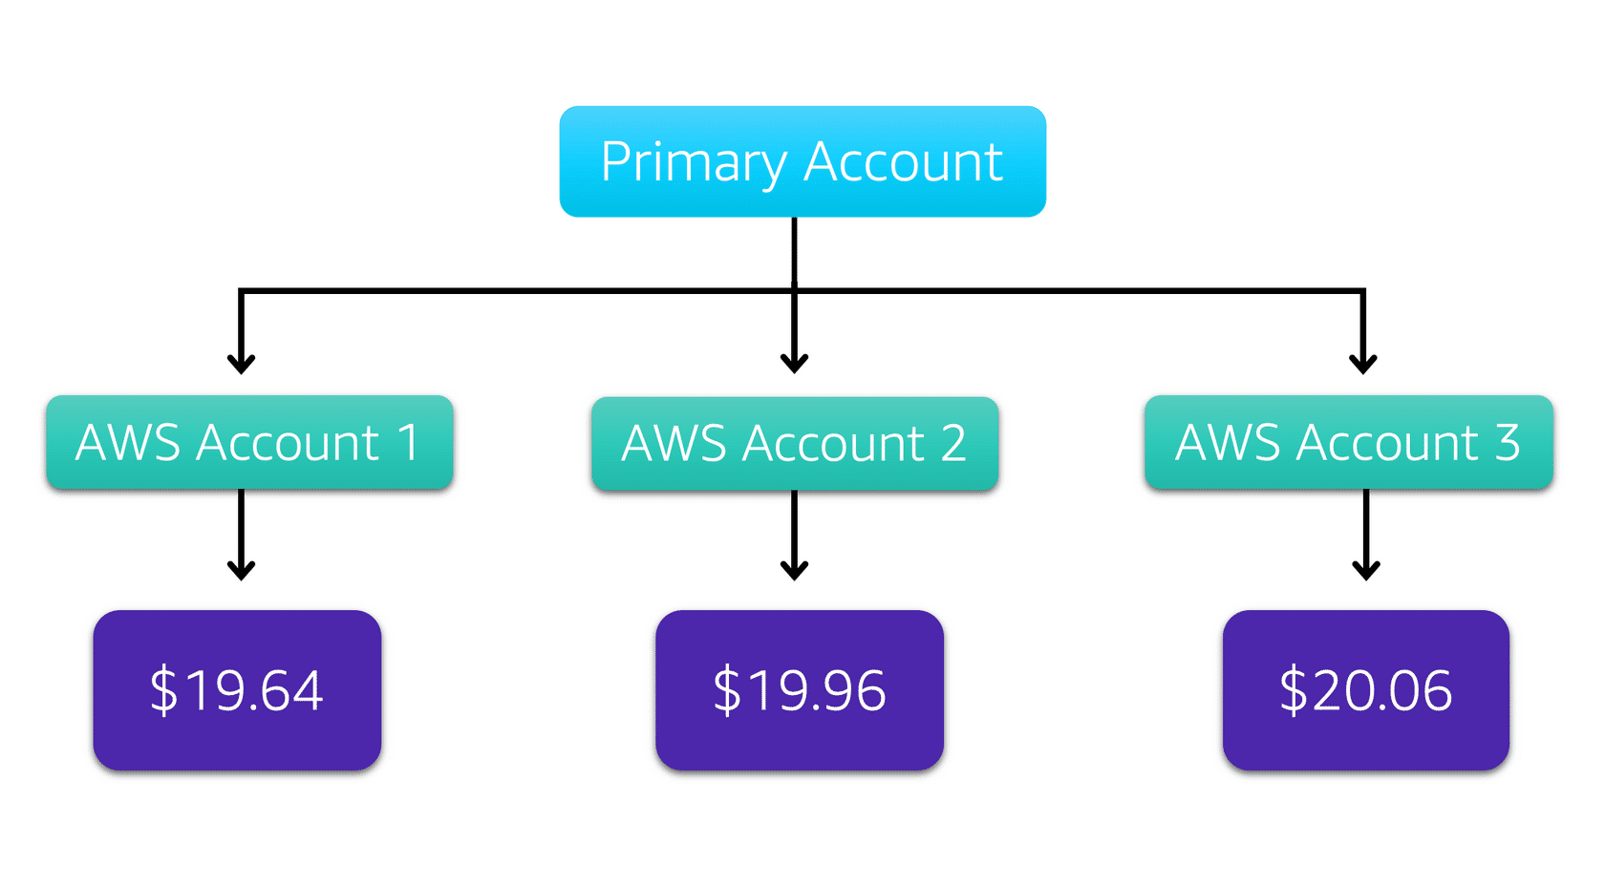

Suppose that you are the business leader who oversees your company’s AWS billing.

Your company has three AWS accounts used for separate departments. Instead of paying each location’s monthly bill separately, you decide to create an organization and add the three accounts.

You manage the organization through the primary account.

## Example: Consolidated billing

To review an example of consolidated billing, select **Start**.

START

**Step 1**



Suppose that you are the business leader who oversees your company’s AWS billing.

Your company has three AWS accounts used for separate departments. Instead of paying each location’s monthly bill separately, you decide to create an organization and add the three accounts.

You manage the organization through the primary account.

1

2

3

**Step 2**

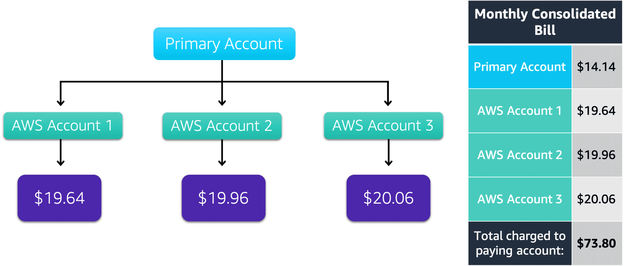

Each month, AWS charges your primary payer account for all the linked accounts in a consolidated bill. Through the primary account, you can also get a detailed cost report for each linked account.

The monthly consolidated bill also includes the account usage costs incurred by the primary account. This cost is not a premium charge for having a primary account.

The consolidated bill shows the costs associated with any actions of the primary account (such as storing files in Amazon S3 or running Amazon EC2 instances).

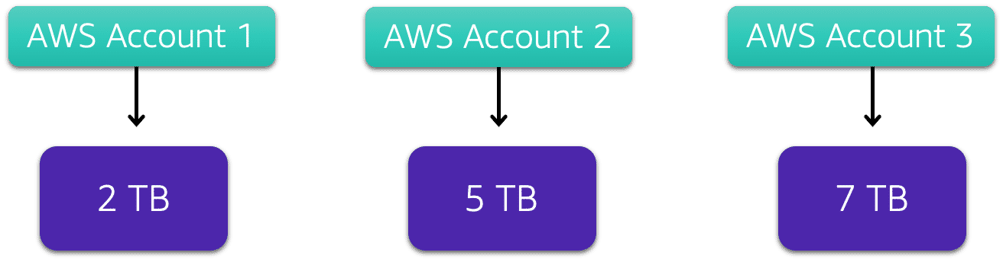

Consolidated billing also enables you to share volume pricing discounts across accounts.

Some AWS services, such as Amazon S3, provide volume pricing discounts that give you lower prices the more that you use the service. In Amazon S3, after customers have transferred 10 TB of data in a month, they pay a lower per-GB transfer price for the next 40 TB of data transferred.

In this example, there are three separate AWS accounts that have transferred different amounts of data in Amazon S3 during the current month:

* Account 1 has transferred 2 TB of data.
* Account 2 has transferred 5 TB of data.
* Account 3 has transferred 7 TB of data.

Because no single account has passed the 10 TB threshold, none of them is eligible for the lower per-GB transfer price for the next 40 TB of data transferred.

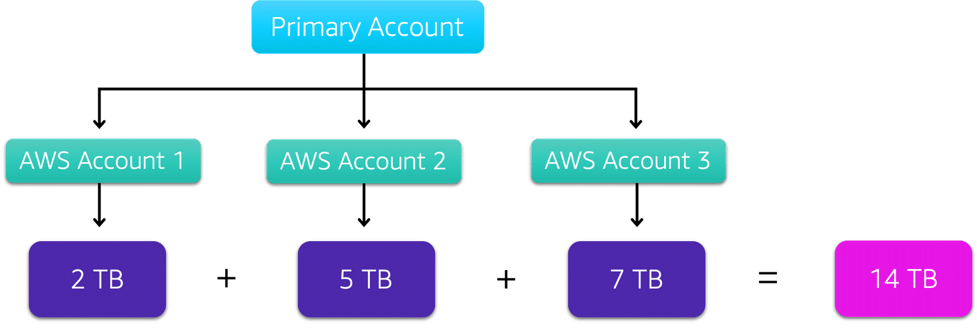

Now, suppose that these three separate accounts are brought together as linked accounts within a single AWS organization and are using consolidated billing.

When the Amazon S3 usage for the three linked accounts is combined (2+5+7), this results in a combined data transfer amount of 14 TB. This exceeds the 10-TB threshold.

With consolidated billing, AWS combines the usage from all accounts to determine which volume pricing tiers to apply, giving you a lower overall price whenever possible. AWS then allocates each linked account a portion of the overall volume discount based on the account's usage.

In this example, Account 3 would receive a greater portion of the overall volume discount because at 7 TB, it has transferred more data than Account 1 (at 2 TB) and Account 2 (at 5 TB).

**AWS Budgets**

Play Video

**Video transcript**

–

As you're ramping up your AWS deployments, you probably want to make sure you're not spending an unbudgeted amount. As with most companies, you want to track costs and make sure you keep within your limits. Introducing AWS Budgets.

Think of a budget for your personal expenses, and you'll be most familiar with AWS Budgets. It allows you to set custom budgets for a variety of scenarios like cost and usage. You will then receive an alert when your costs or usage exceed or are forecasted to exceed your budgeted amount.

Say my budget was a thousand dollars and I want to be notified when I reach 80% of that amount. Well, with Budgets, you can do just that. That means you can be proactively notified if you're going to exceed your budgeted amount for resources.

So let me show you what I'm talking about here with a demo. To get started, you navigate to the billing section of your AWS console, click Budgets, then click Create Budget. Choose a type for your budget. I'll pick Cost. Give your budget a name. Enter an amount. Let's say a thousand dollars as I mentioned earlier, and then click Configure Alert. Next, we set an alert threshold. Let's take that 80%, which means we'll get an alert if we've reached 80% of our budgeted amount. Now let's add an email address. Gotta make sure to blur this out, folks. I get enough spam as it is. Now we click Confirm Budget and Create.

And voila, we have our first budget. How streamlined was that? I think it's safe to say we budgeted our time wisely in that demo.

**AWS Budgets**

**Video transcript**

–

As you're ramping up your AWS deployments, you probably want to make sure you're not spending an unbudgeted amount. As with most companies, you want to track costs and make sure you keep within your limits. Introducing AWS Budgets.

Think of a budget for your personal expenses, and you'll be most familiar with AWS Budgets. It allows you to set custom budgets for a variety of scenarios like cost and usage. You will then receive an alert when your costs or usage exceed or are forecasted to exceed your budgeted amount.

Say my budget was a thousand dollars and I want to be notified when I reach 80% of that amount. Well, with Budgets, you can do just that. That means you can be proactively notified if you're going to exceed your budgeted amount for resources.

So let me show you what I'm talking about here with a demo. To get started, you navigate to the billing section of your AWS console, click Budgets, then click Create Budget. Choose a type for your budget. I'll pick Cost. Give your budget a name. Enter an amount. Let's say a thousand dollars as I mentioned earlier, and then click Configure Alert. Next, we set an alert threshold. Let's take that 80%, which means we'll get an alert if we've reached 80% of our budgeted amount. Now let's add an email address. Gotta make sure to blur this out, folks. I get enough spam as it is. Now we click Confirm Budget and Create.

And voila, we have our first budget. How streamlined was that? I think it's safe to say we budgeted our time wisely in that demo.

In [**AWS Budgets**](https://aws.amazon.com/aws-cost-management/aws-budgets), you can create budgets to plan your service usage, service costs, and instance reservations.

The information in AWS Budgets updates three times a day. This helps you to accurately determine how close your usage is to your budgeted amounts or to the AWS Free Tier limits.

In AWS Budgets, you can also set custom alerts when your usage exceeds (or is forecasted to exceed) the budgeted amount.

**Example: AWS Budgets**

Suppose that you have set a budget for Amazon EC2. You want to ensure that your company’s usage of Amazon EC2 does not exceed $200 for the month.

In AWS Budgets, you could set a custom budget to notify you when your usage has reached half of this amount ($100). This setting would allow you to receive an alert and decide how you would like to proceed with your continued use of Amazon EC2.

To learn more, select each marker.

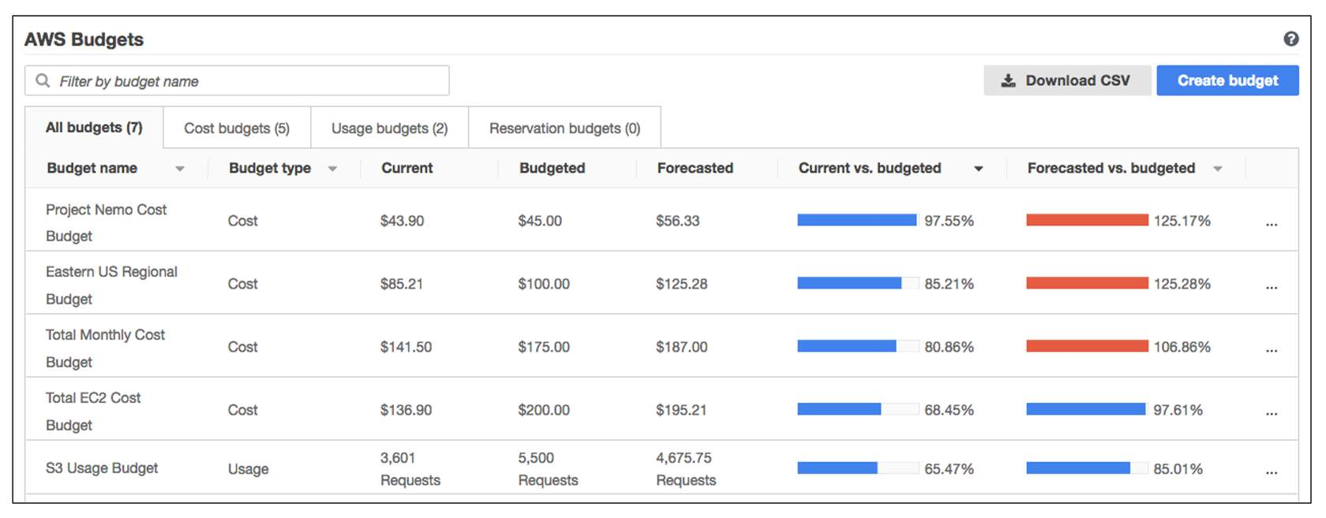

# AWS Cost Explorer

Play Video

**Video transcript**

–

As we have already discussed, AWS has a variable cost model, and you only pay for what you use. You don't have one fixed billed amount at the end of every month. Instead, it fluctuates with the resources you use and how you use them. Because of this cost model, it's really important that you can drill down into your bill and see just how you are spending money.

AWS has a service called the AWS Cost Explorer, and it's a console-based service that allows you to visually see and analyze how you are spending money with AWS. It will show you which services you are spending the most money on, and it gives you 12 months of historical data, so you can track your spending over time. That way, if you see a bump in spending on, say, EC2 from October to December, you can then use that data to go on and figure out why exactly that happened.

Let's take a look at AWS Cost Explorer in my own AWS account. You can see I am logged in to the console, and I'm going to type into the search Cost Explorer. From here, I am brought to the Cost Management dashboard, and I will click on Cost Explorer. You can see this is showing me the last six months of cost associated with my account, and it's currently grouped by service. I can change the timeframe it's showing me to eight months and change the data to be grouped by different attributes, and I'll go ahead and select Region. I can group by other attributes as well.

One important grouping to note is to group by tag. Many resources in AWS are taggable. Tags are essentially user-defined key-value pairs. So you can tag an EC2 instance with a specific project name or a database with the same project name, and then you can come into the AWS Cost Explorer, filter by tag, and see all of the expenses associated with that tag. Cost Explorer also allows you to create custom reports.

So now what I'm going to do is create a report on the daily cost for the month of January of this year. I'm going to group by service. You can see that the cost of the services is generally the same every day, except that I used more EC2 on some days than others. I can then save this report and come back to it when it is needed.

So as you can see, Cost Explorer gives you some powerful defaults for reports, but you can build your own custom ones as well. This will help you identify cost drivers and take action when necessary to curb spending. Cost optimization is a priority you should be paying close attention to, and you can use the Cost Explorer to help get you going in the right direction.

**AWS Cost Explorer**

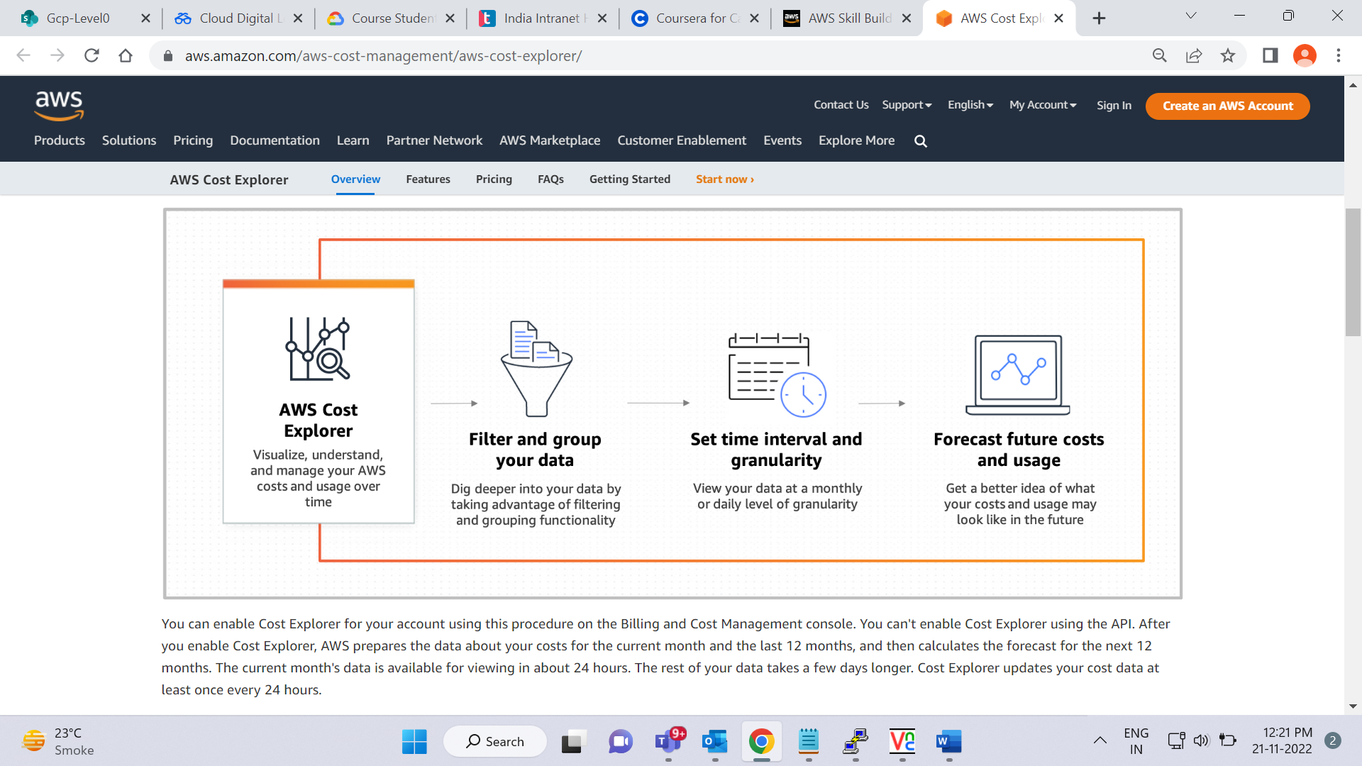

[**AWS Cost Explorer**](https://aws.amazon.com/aws-cost-management/aws-cost-explorer/) is a tool that enables you to visualize, understand, and manage your AWS costs and usage over time.

AWS Cost Explorer includes a default report of the costs and usage for your top five cost-accruing AWS services. You can apply custom filters and groups to analyze your data. For example, you can view resource usage at the hourly level.

**Example: AWS Cost Explorer**

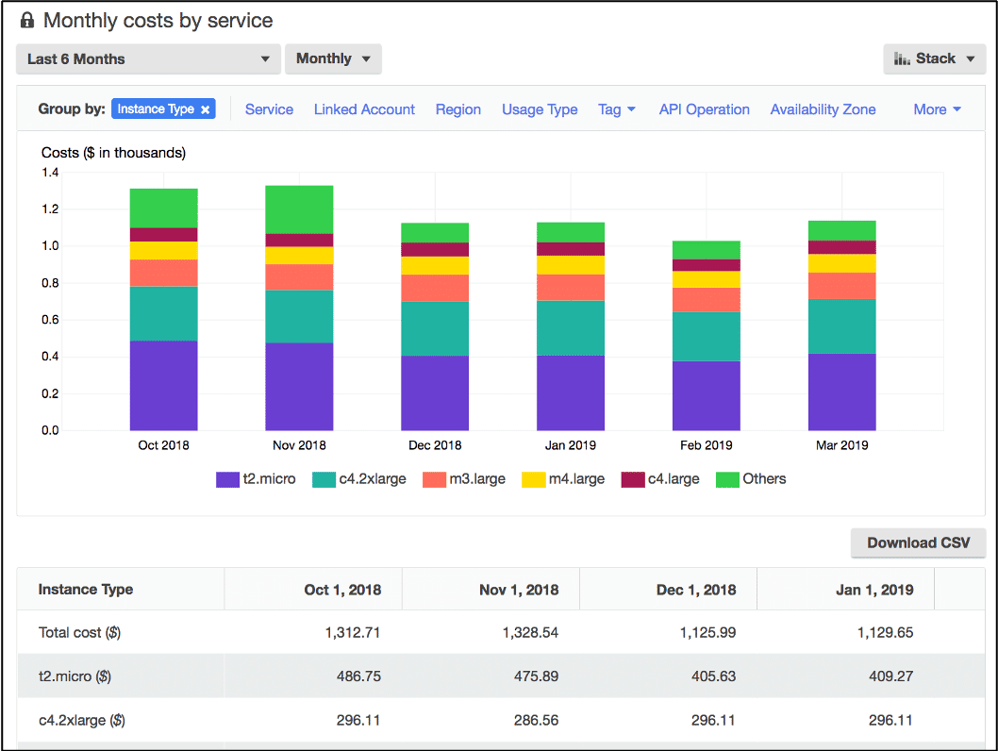

This example of the AWS Cost Explorer dashboard displays monthly costs for Amazon EC2 instances over a 6-month period. The bar for each month separates the costs for different Amazon EC2 instance types (such as t2.micro or m3.large).

By analyzing your AWS costs over time, you can make informed decisions about future costs and how to plan your budgets.

**AWS Support plans**

Play Video

**Video transcript**

–

One of the great things about AWS is no matter how big or small your business is, you're never alone. From small startups to large enterprises, private sector, and public, all businesses have support options available that are designed to fit your specific needs.

To begin with, every customer automatically gets AWS Basic support, no cost at all. Any customer can access support functions like 24/7 access to customer service, documentation, whitepapers, support forums, AWS Trusted Advisor, and the AWS Personal Health Dashboard. It's a personalized view of the health of AWS services and any alerts when your resources might be impacted. These functions are free for everyone, but as you begin to move mission critical workloads into AWS, we offer higher levels of support to match your levels of need.

The next tier is our Developer tier, which includes everything in the Basic support level. Plus, you can now email customer support directly with a 24 hour response time on any questions you have. And responses of less than 12 hours in case your systems are impaired. This is a great tier for businesses that are experimenting with AWS or setting up tests or proofs of concept.

Now, as you begin to take production workloads live, we find customers are more successful advancing to the Business tier. Everything in the previous tiers, plus Trusted Advisor now opens up the entire suite of checks for your account. You are given direct phone access to our support team that has a four hour response SLA. If your production system is impaired, and a one hour SLA for production systems down. Additionally, as part of the Business tier, we provide access to infrastructure event management, where for an extra fee, we can help you plan for massive events like brand new launches or global advertising blitzes.

Finally, for companies running mission critical workloads, we recommend the Enterprise level support. It has everything in the previous tiers. Plus a 15 minute SLA for business critical workloads, a dedicated technical account manager for TAM. They will coordinate access to programs and other AWS experts as needed.

Let's talk a bit more specifically about the job of a TAM. TAMs are part of the concierge support team that comes with Enterprise level support. They specialize not only in proactively monitoring your environment and assisting with optimizations, but provide infrastructure event management, Well-Architected reviews, and operations reviews.

What's a Well-Architected review, You ask? Well, keeping it simple, TAMs work with customers to review architectures using the Well-Architected Framework. Architectures are checked against the five pillars of the Well-Architected Framework: Operational Excellence, Security, Reliability, Performance Efficiency, and Cost Optimization. As you can see, the job of a TAM is much more than just handling trouble tickets. AWS Support looks at the customer holistically, not just if they have problems, but how can we help them be successful?

And that's the mission of AWS Support. To learn more about AWS Support, including pricing structures for the plans, go to [aws.amazon.com/premiumsupport](https://aws.amazon.com/premiumsupport).

**AWS Support**

AWS offers four different [**Support plans**](https://aws.amazon.com/premiumsupport/plans/) to help you troubleshoot issues, lower costs, and efficiently use AWS services.

You can choose from the following Support plans to meet your company’s needs:

* Basic
* Developer
* Business
* Enterprise On-Ramp
* Enterprise

**Basic Support**

**Basic Support** is free for all AWS customers. It includes access to whitepapers, documentation, and support communities. With Basic Support, you can also contact AWS for billing questions and service limit increases.

With Basic Support, you have access to a limited selection of AWS Trusted Advisor checks. Additionally, you can use the **AWS Personal Health Dashboard**, a tool that provides alerts and remediation guidance when AWS is experiencing events that may affect you.

If your company needs support beyond the Basic level, you could consider purchasing Developer, Business, Enterprise On-Ramp, and Enterprise Support.

**Developer, Business, Enterprise On-Ramp, and Enterprise Support**

The Developer, Business, Enterprise On-Ramp, and Enterprise Support plans include all the benefits of Basic Support, in addition to the ability to open an unrestricted number of technical support cases. These Support plans have pay-by-the-month pricing and require no long-term contracts.  
  
The information in this course highlights only a selection of details for each Support plan. A complete overview of what is included in each Support plan, including pricing for each plan, is available on the [AWS Support](https://aws.amazon.com/premiumsupport/plans/) site.  
  
In general, for pricing, the Developer plan has the lowest cost, the Business and Enterprise On-Ramp plans are in the middle, and the Enterprise plan has the highest cost.

To learn more, select the **+** symbol next to each category.

**Developer Support**

–

Customers in the **Developer Support** plan have access to features such as:

* Best practice guidance
* Client-side diagnostic tools
* Building-block architecture support, which consists of guidance for how to use AWS offerings, features, and services together

For example, suppose that your company is exploring AWS services. You’ve heard about a few different AWS services. However, you’re unsure of how to potentially use them together to build applications that can address your company’s needs. In this scenario, the building-block architecture support that is included with the Developer Support plan could help you to identify opportunities for combining specific services and features.

**Business Support**

–

Customers with a **Business Support** plan have access to additional features, including:

* Use-case guidance to identify AWS offerings, features, and services that can best support your specific needs
* All AWS Trusted Advisor checks
* Limited support for third-party software, such as common operating systems and application stack components

Suppose that your company has the Business Support plan and wants to install a common third-party operating system onto your Amazon EC2 instances. You could contact AWS Support for assistance with installing, configuring, and troubleshooting the operating system. For advanced topics such as optimizing performance, using custom scripts, or resolving security issues, you may need to contact the third-party software provider directly.

**Enterprise On-Ramp Support**

–

In November 2021, AWS opened enrollment into AWS Enterprise On-Ramp Support plan. In addition to all the features included in the Basic, Developer, and Business Support plans, customers with an Enterprise On-Ramp Support plan have access to:

* A pool of Technical Account Managers to provide proactive guidance and coordinate access to programs and AWS experts
* A Cost Optimization workshop (one per year)
* A Concierge support team for billing and account assistance
* Tools to monitor costs and performance through Trusted Advisor and Health API/Dashboard

Enterprise On-Ramp Support plan also provides access to a specific set of proactive support services, which are provided by a pool of Technical Account Managers.

* Consultative review and architecture guidance (one per year)
* Infrastructure Event Management support (one per year)
* Support automation workflows
* 30 minutes or less response time for business-critical issues

**Enterprise Support**

–

In addition to all features included in the Basic, Developer, Business, and Enterprise On-Ramp support plans, customers with Enterprise Support have access to:

* A designated Technical Account Manager to provide proactive guidance and coordinate access to programs and AWS experts
* A Concierge support team for billing and account assistance
* Operations Reviews and tools to monitor health
* Training and Game Days to drive innovation
* Tools to monitor costs and performance through Trusted Advisor and Health API/Dashboard

The Enterprise plan also provides full access to proactive services, which are provided by a designated Technical Account Manager:

* Consultative review and architecture guidance
* Infrastructure Event Management support
* Cost Optimization Workshop and tools
* Support automation workflows
* 15 minutes or less response time for business-critical issues

**Technical Account Manager (TAM)**

The Enterprise On-Ramp and Enterprise Support plans include access to a **Technical Account Manager (TAM)**.  
  
The TAM is your primary point of contact at AWS. If your company subscribes to Enterprise Support or Enterprise On-Ramp, your TAM educates, empowers, and evolves your cloud journey across the full range of AWS services. TAMs provide expert engineering guidance, help you design solutions that efficiently integrate AWS services, assist with cost-effective and resilient architectures, and provide direct access to AWS programs and a broad community of experts.  
  
For example, suppose that you are interested in developing an application that uses several AWS services together. Your TAM could provide insights into how to best use the services together. They achieve this, while aligning with the specific needs that your company is hoping to address through the new application.

# AWS Marketplace

Play Video

**Video transcript**

–

Another huge way that AWS supports your enterprise is through the AWS Marketplace. The AWS Marketplace is a curated digital catalog that streamlines your steps to find, deploy and manage third party software running in your AWS architecture, all while providing a range of payment options, and this allows you to accelerate innovation while rapidly and securely deploying a wide range of solutions, while also reducing your total cost of ownership.

To help us understand this more, I wanna talk about what the AWS Marketplace brings to the table, and how it can help you improve your speed and agility with AWS. The first key way that the AWS Marketplace helps customers, is that instead of needing to build, install and maintain the foundational infrastructure needed to run these third party applications in the marketplace, customers have options like one-click deployment that allows them to quickly procure and use products from thousands of software sellers right when you need them.

Now, as you may know, some third party vendors historically have annual contracts for on-premises data centers. You might be wondering, is it the same with an AWS? Well, every vendor can choose what options are available, but almost every vendor in the marketplace will allow you to use any annual licenses you already own and credit them for AWS deployment. But more importantly, as you move forward, most vendors in the marketplace also offer on-demand pay-as-you-go options. These flexible pricing plans give you more options to pay for the software, the way you actually use it without wasted unused licenses weighing down your balance sheets.

Many vendors even offer free trials or Quick Start plans to help you experiment and learn about their offerings. Because they know just like AWS itself, the best way to see if something works for you is to just run it. Even for large enterprises that are used to negotiating custom rates and discount vendors, well the AWS Marketplace can help. The marketplace offers a number of enterprise-focused features, such as custom terms and pricing, where you can manage custom licensing agreements. A private marketplace, where you can create a custom catalog of pre-approved software solutions that meet your specific legal or security standards. Integration into your procurement systems, and a range of cost management tools just to name a few benefits. To learn more about the AWS Marketplace, go to aws.amazon.com/marketplace.

**AWS Marketplace**

[**AWS Marketplace**](https://aws.amazon.com/marketplace) is a digital catalog that includes thousands of software listings from independent software vendors. You can use AWS Marketplace to find, test, and buy software that runs on AWS.

For each listing in AWS Marketplace, you can access detailed information on pricing options, available support, and reviews from other AWS customers.

You can also explore software solutions by industry and use case. For example, suppose that your company is in the healthcare industry. In AWS Marketplace, you can review use cases that software helps you to address, such as implementing solutions to protect patient records or using machine learning models to analyze a patient’s medical history and predict possible health risks.

**AWS Marketplace categories**

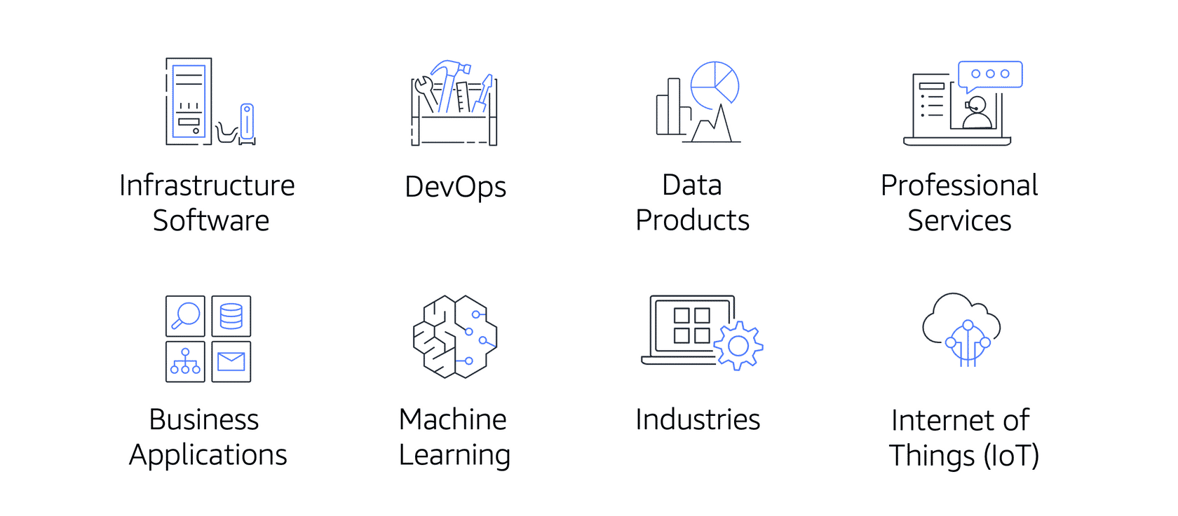

AWS Marketplace offers products in several categories, such as Infrastructure Software, DevOps, Data Products, Professional Services, Business Applications, Machine Learning, Industries, and Internet of Things (IoT).

Within each category, you can narrow your search by browsing through product listings in subcategories. For example, subcategories in the DevOps category include areas such as Application Development, Monitoring, and Testing.